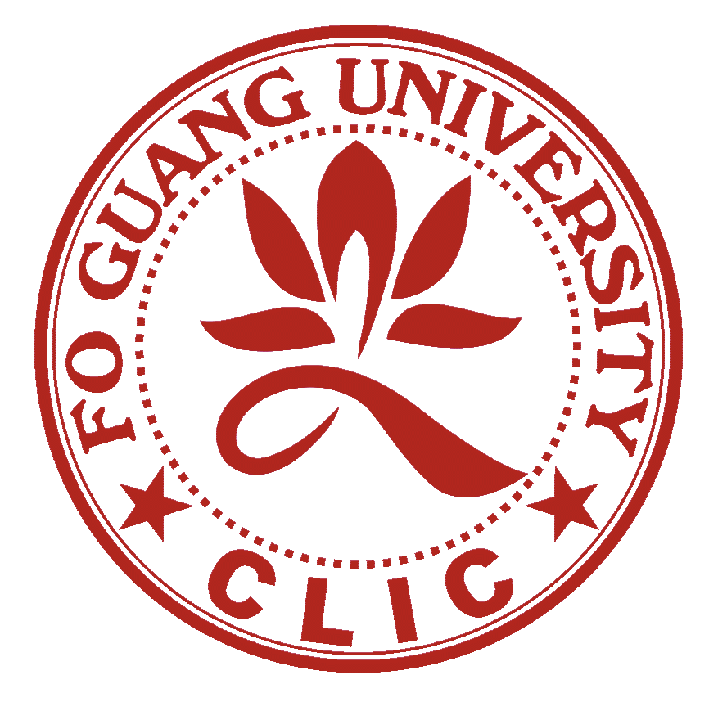

Fo Guang University

CHINESE LANGUAGE INSTRUCTION CENTER

Application Form (Please Type or Print)

Academic Term for which you are applying

□Spring □Summer □Autumn □Winter Year

Personal Information

Name (family name, given name)

Present Mailing Address

Country, Zip Code or Mailing Code

Phone

Facsimile

Date Present Address Expires

Email Address

Name in Chinese

Permanent Mailing Address

Country, Zip Code or Mailing Code

Phone

Facsimile

Date of Birth Place of Birth

Citizenship

Are you married? □Yes □No Are you □Male □Female
Do you have children? □Yes □No Ages
Will your family accompany you to Taiwan? □Yes □No
How do you rate your health at this particular time? □Excellent □Good □Fair □Poor

Current school status:

□Undergraduate □Graduate □Unaffiliated

Name of College or University currently attended

Major

Degree expected Date
Applicants for Academic Year (Autumn/Spring Terms) and Summer Intensive Program must submit academic transcripts from current or most recently attended schools.

Previous colleges or universities attended:
from to Degree
from to Degree
from to Degree
For any period not covered above (except summer vacations) what was/is your occupation?

Academic Information
Date you began Chinese language study Where?
Please list Chinese language course completed: first, spoken Chinese; second, modern written Chinese; and third, literary (classical) Chinese.
Name of Course No. of Semesters/Quarters Credits Where When
1.
2.
3.
Give dates, length of stay, and purpose of previous residence in Chinese speaking areas:
Taiwan
PRC
Other
Language background and competence in other languages:

Academic Year Program (Autumn/Spring Terms) Only
If now working toward an advanced degree, state thesis topic or research area (as precisely as it can be defined):

References have been requested from: (three references are required - sent in sealed and signed envelopes with application, if possible)
1.
2.
3.
Are you including an Academic Year Financial Aid Application Form? □Yes □No
(No Aid available for Summer Term) Signed
Please attach a Statement of Purpose (500 words or less).
Your application folder is not complete without references and transcripts from all college work. Please submit the application and statement of purpose along with your application fees by no later than each semester’s deadline to:

Chinese Language Instruction Center
Fo Guang University
No. 257 Zhongshan Rd. Sec. 3, Yilan City, 260, Taiwan, ROC
From Taiwan:
260宜蘭市中山路三段257號
佛光大學語文教育中心

Fo Guang University

CHINESE LANGUAGE INSTRUCTION CENTER

Reference (Autumn/Spring Term Only)
(Name of applicant) is applying for admission to the
Academic Year Program
Students are permitted to waive their right of access to recommendations.
The following signed statement indicates the wish of the applicant regarding this recommendation.
□ I do waive my right to inspect the contents of the following recommendation.
□ I do not waive my right to inspect the contents of the following recommendation.
(Applicant's Signature)
Referee Title
Institution
How well, how long, and under what conditions have you known the applicant?

The Committee on Admission and Awards is particularly concerned with the candidate's future potential and promise in his/her chosen field; his/her emotional stability; evidence of drive and motivation; character and sense of responsibility; and whether or not you feel this is an appropriate time in the student's academic career for advanced intensive language study in Taiwan.
Date Signed
Please return this reference to the applicant in a sealed envelope with your signature across the seal. If you prefer, you may mail it directly to the Chinese Language Instruction Center, Fo Guang University; 257, Zhong-shan Rd. Sec. 3, Yi-lan City, 260, Taiwan, ROC, by April 30 (Oct. 30 for Spring Term).

Fo Guang University

CHINESE LANGUAGE INSTRUCTION CENTER

Reference (Autumn/Spring Term Only)
(Name of applicant) is applying for admission to the
Academic Year Program
Students are permitted to waive their right of access to recommendations.
The following signed statement indicates the wish of the applicant regarding this recommendation.
□ I do waive my right to inspect the contents of the following recommendation.
□ I do not waive my right to inspect the contents of the following recommendation.
(Applicant's Signature)
Referee Title
Institution
How well, how long, and under what conditions have you known the applicant?

The Committee on Admission and Awards is particularly concerned with the candidate's future potential and promise in his/her chosen field; his/her emotional stability; evidence of drive and motivation; character and sense of responsibility; and whether or not you feel this is an appropriate time in the student's academic career for advanced intensive language study in Taiwan.
Date Signed
Please return this reference to the applicant in a sealed envelope with your signature across the seal. If you prefer, you may mail it directly to the Chinese Language Instruction Center, Fo Guang University; 257, Zhong-shan Rd. Sec. 3, Yi-lan City, 260, Taiwan, ROC, by April 30 (Oct. 30 for Spring Term).

Fo Guang University

CHINESE LANGUAGE INSTRUCTION CENTER

Reference (Autumn/Spring Term Only)
(Name of applicant) is applying for admission to the
Academic Year Program
Students are permitted to waive their right of access to recommendations.
The following signed statement indicates the wish of the applicant regarding this recommendation.
□ I do waive my right to inspect the contents of the following recommendation.
□ I do not waive my right to inspect the contents of the following recommendation.
(Applicant's Signature)
Referee Title
Institution
How well, how long, and under what conditions have you known the applicant?

The Committee on Admission and Awards is particularly concerned with the candidate's future potential and promise in his/her chosen field; his/her emotional stability; evidence of drive and motivation; character and sense of responsibility; and whether or not you feel this is an appropriate time in the student's academic career for advanced intensive language study in Taiwan.
Date Signed
Please return this reference to the applicant in a sealed envelope with your signature across the seal. If you prefer, you may mail it directly to the Chinese Language Instruction Center, Fo Guang University; 257, Zhong-shan Rd. Sec. 3, Yi-lan City, 260, Taiwan, ROC, by April 30 (Oct. 30 for Spring Term).

Fo Guang University

CHINESE LANGUAGE INSTRUCTION CENTER

Academic Year Program (Autumn/Spring Terms)

Financial Aid Details
- All Academic Year (Autumn/Spring Terms) applicants are eligible for financial aid and all applications are judged by the same criteria.
- Admission decisions do not take financial need into consideration. Fellowship decisions are made after admission decisions.
- CLIC's fellowship funds are limited. It is therefore not possible to provide full support for any student and some students may not receive aid from CLIC. All CLIC awards should be considered supplementary to other resources available to the student.
- Fellowship decisions are made on the combined bases of merit and need (as nearly as these factors can be determined by the Committee on Admissions and Awards) and are based on the overall application and financial aid statement. The fairest use of our limited fellowship funds is possible only if financial aid applications are completed candidly and realistically. One may do oneself an unnecessary disservice by too optimistic an estimate of the resources likely to be available (loans are not considered a part of these resources for purposes of computing fellowships). Conversely, an understatement of your resources may unfairly disadvantage other applicants.
- Detailed information will be sent to you prior to your departure, but in the interim you may find the following figures helpful in preliminary planning for the year and in completing the financial aid application.
- Attendance fees: Currently set at US$8,000 for the Autumn/Spring Academic Program (two semesters) and US$2,000 for the 8-week Summer Intensive Program Term.
- Air fare: Check with your travel agent regarding current round-trip international airfares from your location to Taipei.
- Maintenance: This figure varies widely among individuals. Recent experience shows that the average single student requires about US$600 per month. This covers housing, food and some incidental expenses—a rather Spartan existence.
- Insurance: If not covered by continuing coverage from home, annual insurance plans can range from $100 to $1,000 depending on coverage. Insurance options will be given in more detail in the Student Information Packet that will be sent out to admitted students.
- Books: Costs per academic term range from US$30–50 depending on the materials used.

Financial Aid application deadline: April 30 for Autumn Term (October 30 for Spring Term)

Fo Guang University

CHINESE LANGUAGE INSTRUCTION CENTER

Academic Year Program (Autumn/Spring Terms)

Financial Aid Application
List scholarships or fellowships you have received in the past three years:

List any scholarships, fellowships, or grants for which you have or will apply this academic year
(i.e., Fulbright-Hays, FLAS, Blakemore, etc.):

Anticipated Sources of Support Liabilities
Family/Personal Income/Savings Debt
Scholarship/grant Educational Loans
Other
Loans contemplated for this academic year (not
considered when determining need)
Other sources (itemize)
TOTAL TOTAL

I certify that the above information is complete and true to my knowledge and I realize that any false statement will disqualify me for admission to the Chinese Language Instruction Center, Fo Guang University.
Signature: Date:

Financial Aid application deadline: April 30 for Autumn Term (October 30 for Spring Term)

